| **Job Sheet** |
| --- |

| **Module** | **:** | IoT Fundamentals | **Module Code** | **:** | EC33105FP | |
| --- | --- | --- | --- | --- | --- | --- |
|  |  |  |  |  |  | |
| **Job No** | **:** | 2 | **Duration** | **:** | F/T: | 2 hours |
|  |  |  |  |  | P/T: |  |

| **Job Title** | **:** | Editor, Pins and Outputs |
| --- | --- | --- |
|  |  |  |
| **Objectives** | **:** | 1. Prepare RPi and Upswift 2. Connect LED to RPi Pins 3. Execute blink LED program using Editor |

**Tools, Equipment and Materials**

| PC |
| --- |
| RPi with microSD |
| RPi Power Adaptor  LEDs x 3  Breadboard  220 ohm x 3  4G WiFi Router |
|  |

**Number of Tasks to Complete**: 4

By the end of this job sheet you would be blinking a LED as shown:

<https://youtu.be/QCVH6Gcaabw>

**Part A: Prepare RPi and Upswift (0.5 hour)**

Before performing any hardware configurations, we need to ensure that the RPi is accessible remotely.

YOU MUST HAVE COMPLETED JOB 1 BEFORE DOING THIS

**Task 1 – Prepare RPi and UpSwift**

Perform the following steps to setup RPi:

1. Connect only the power adaptor to RPi.
2. Turn on the power
3. Go to <https://dashboard.upswift.io/dashboard/> and login. The device would be **offline**.

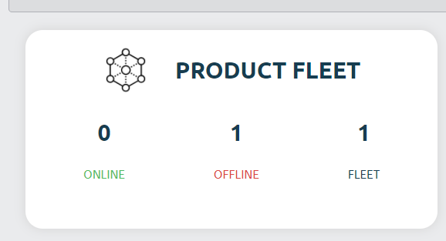

1. Wait for a while and refresh the web page by clicking . Your device should appear online after 1 - 2 mins.

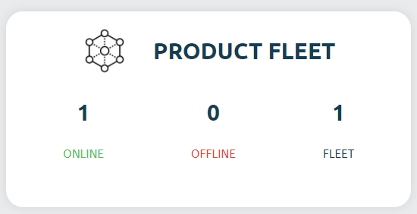

1. On the left side of your menu, click on the **Control** option under Control center.



1. On the page center, select your device and click open session.

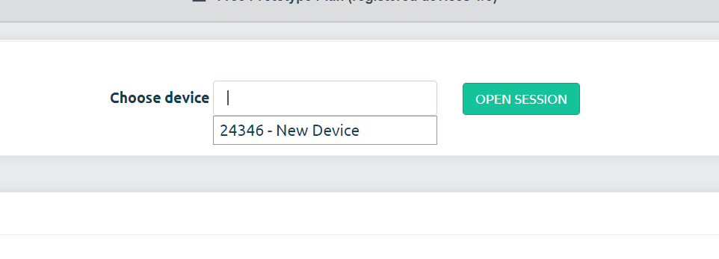

1. For the prompt, click **Open Remote Control.**

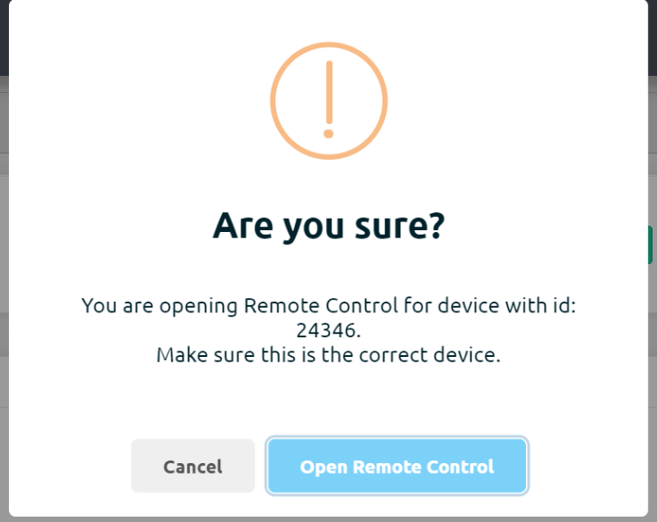

1. You will be shown a secret key. Click on **Copy to clipboard** button

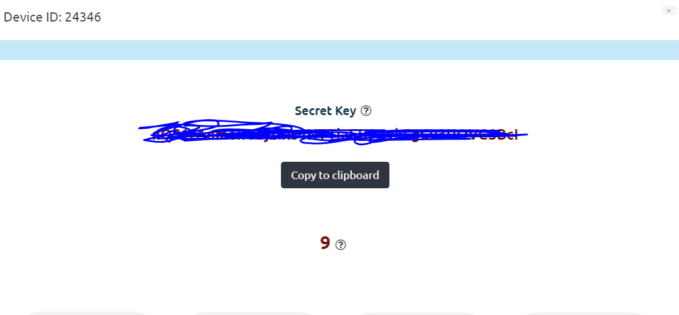

1. Once the timer is up, click on the **Open Remote Control** button.



1. **Paste** the **secret key** in the input text box and change username to **pi**. Click on **Connect**.

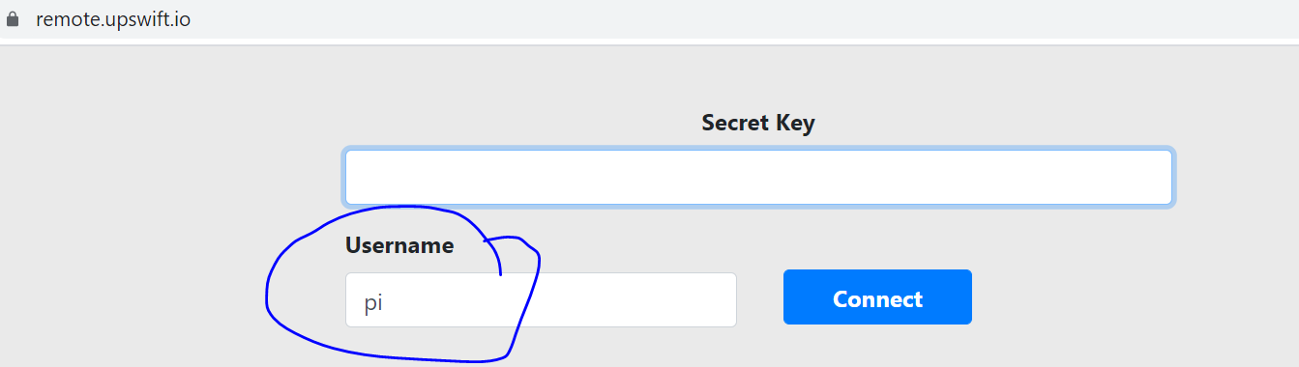

1. You will be presented with a browser based RPi terminal.

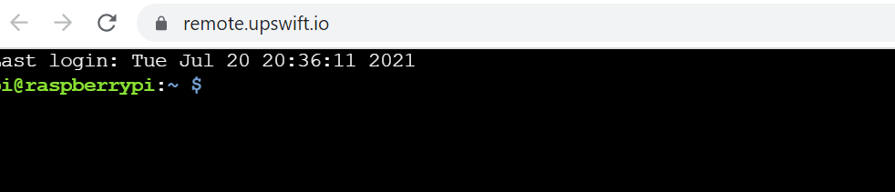

**Part B: Connect LED to RPi Pins**

The RPi pinout is as follows:

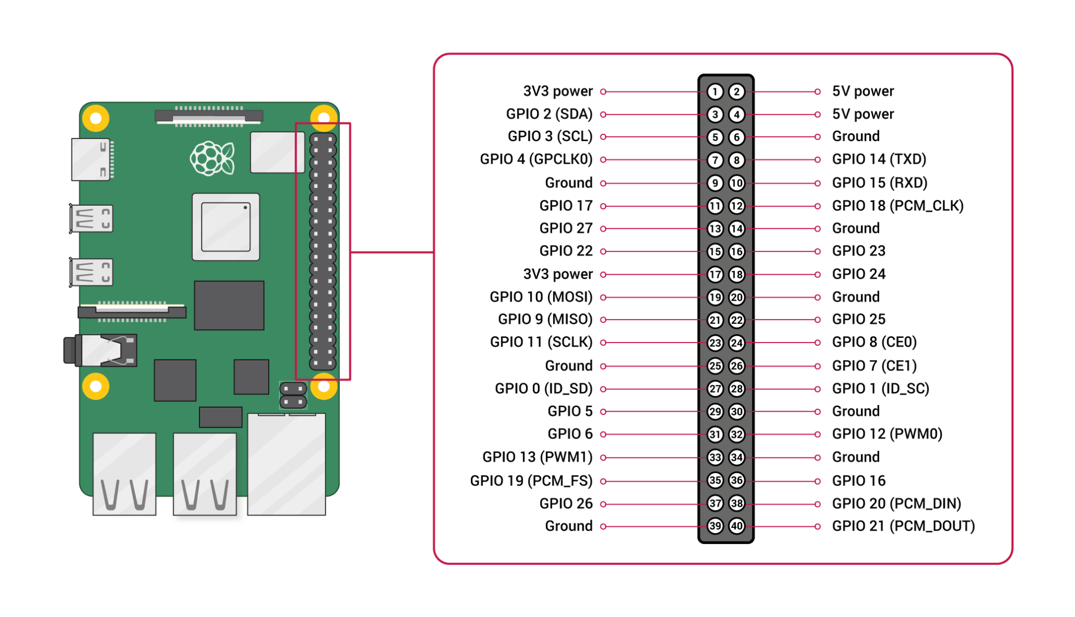

Another thing to note is that the LED has got a polarity !

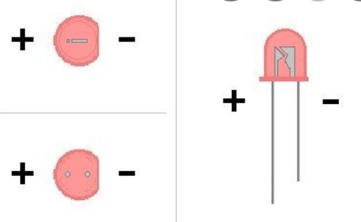

**Task 2 – Connect LED to RPi**

Perform the following steps

1. Connect GPIO extension board from RPi to breadboard.

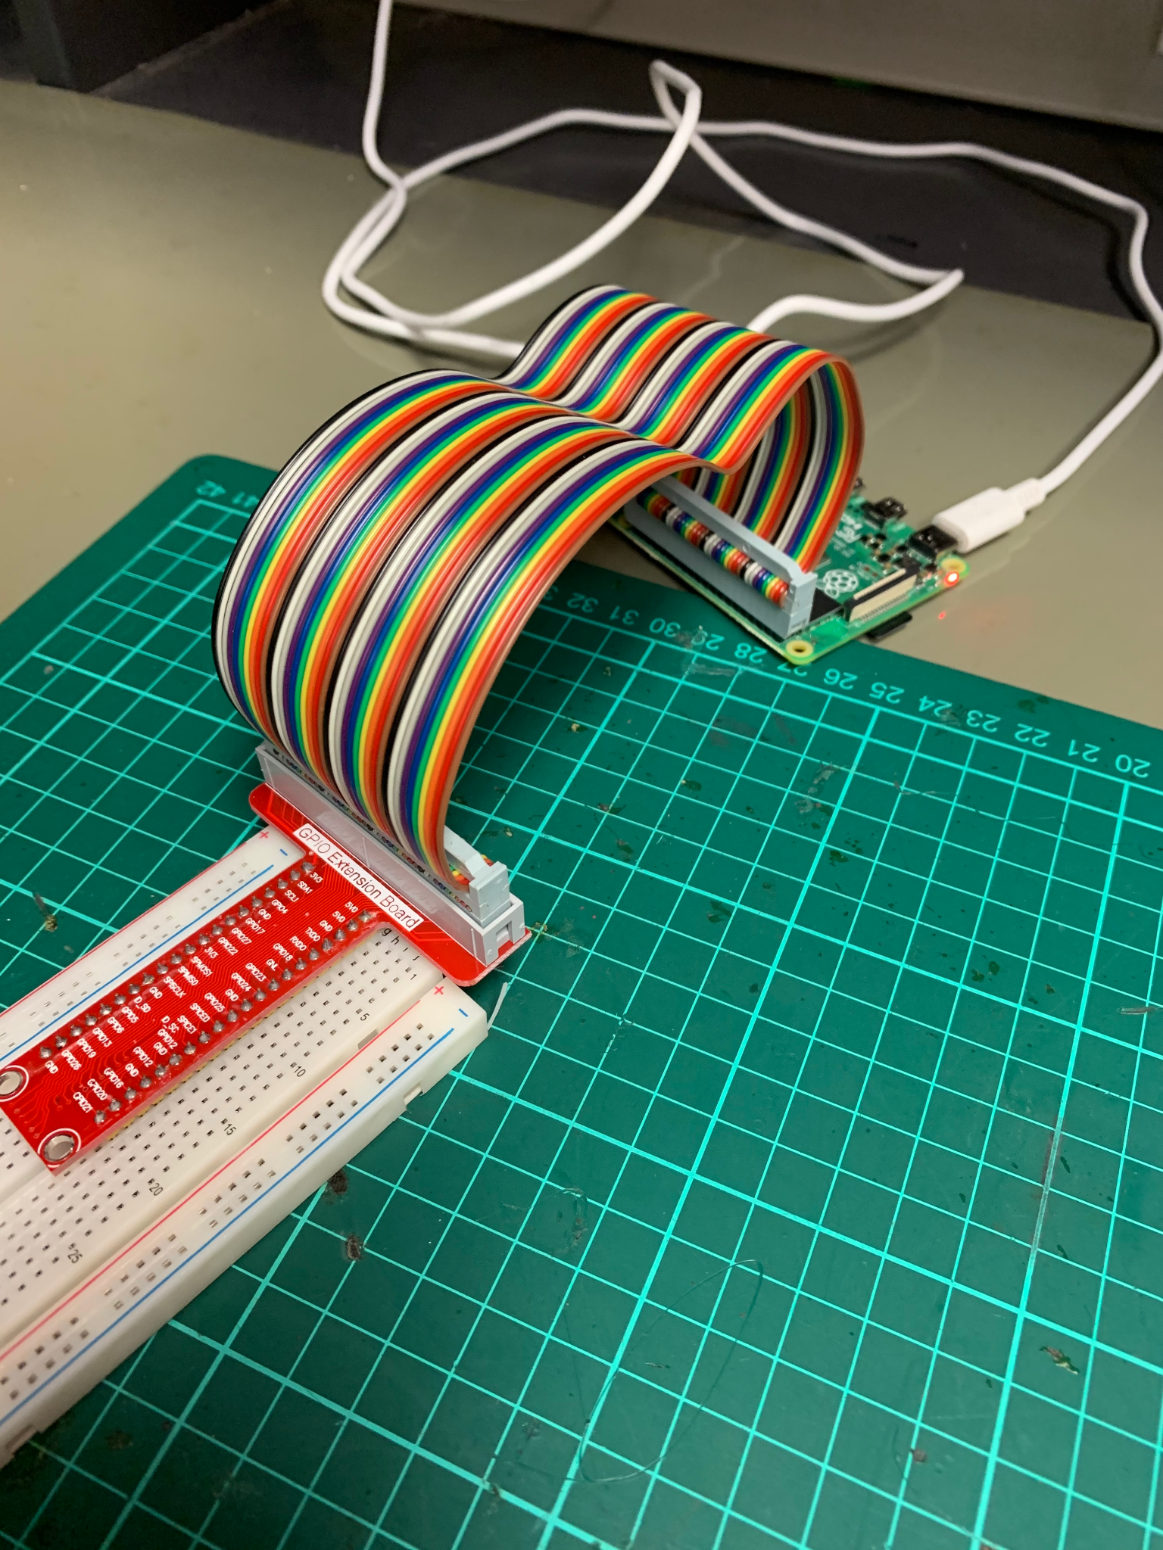

1. Connect Anode(+) of LED to one side 220 ohm resistor using breadboard
2. Connect Cathode(-) of LED to GND of RPi using breadboard.
3. Connect the other side of the 220 ohm resistor to GPIO 23 of RPi using a breadboard.
4. Final circuit should look like this.

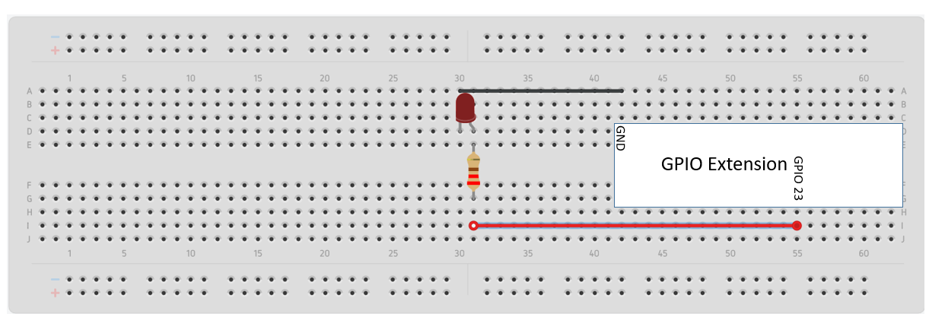

.

**Task 3 – Execute blink program**

1. Follow task one to open a remote terminal as shown.



1. Run the command **sudo nano job2.py** in the terminal. You will be presented with the nano code editor.

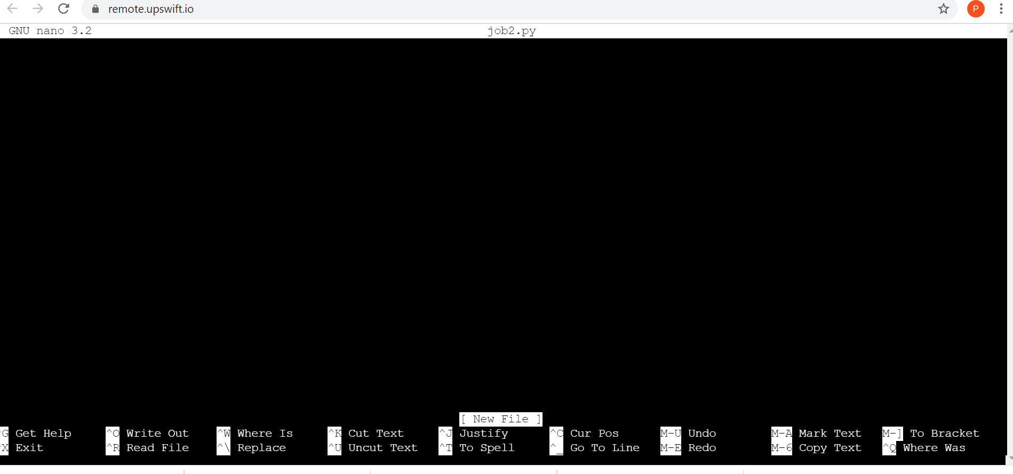

1. Copy the code found at <https://github.com/Prakashash18/iot-fundamentals/blob/main/job2.py>
2. Paste it into the nano editor by right clicking and pasting.

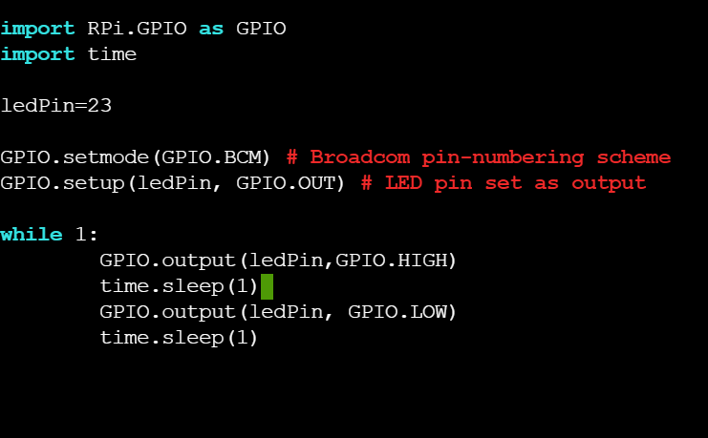

1. [Keyboard] Press CTRL + X to save your work. You will be prompted with the following message.

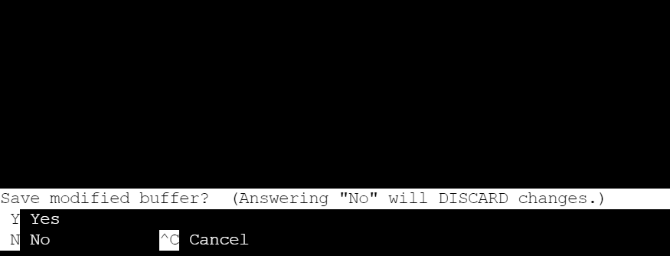

1. [Keyboard] Press **y** and hit **Enter**
2. On the terminal, run **python job2.py** to execute the code.



1. You should see your LED blinking.

<https://youtu.be/QCVH6Gcaabw>

1. To stop the code on the terminal, press CTRL and C.

**Task 4 – Work Challenge**

You are working at ABC IoT Pte Ltd as a technician. As part of the research team, you are asked to **add two more** LEDs to an existing blinking LED solution prototyped using a Raspberry Pi.

You are to ensure that all the LEDs blink at the same rate i.e. on and off at the same time.

Show your working solution to your supervisor/lecturer.

**Questions**

1. What is the purpose of the 220 ohm resistor ? Hint, it’s to limit…..



1. Which line of code caused the LED to light up?



1. Which line of code caused the LED to turn off?

